# Data Viz Lab 1: Understanding Tableau Public workspace

NAME:Pavithiran.V Roll no:235229122

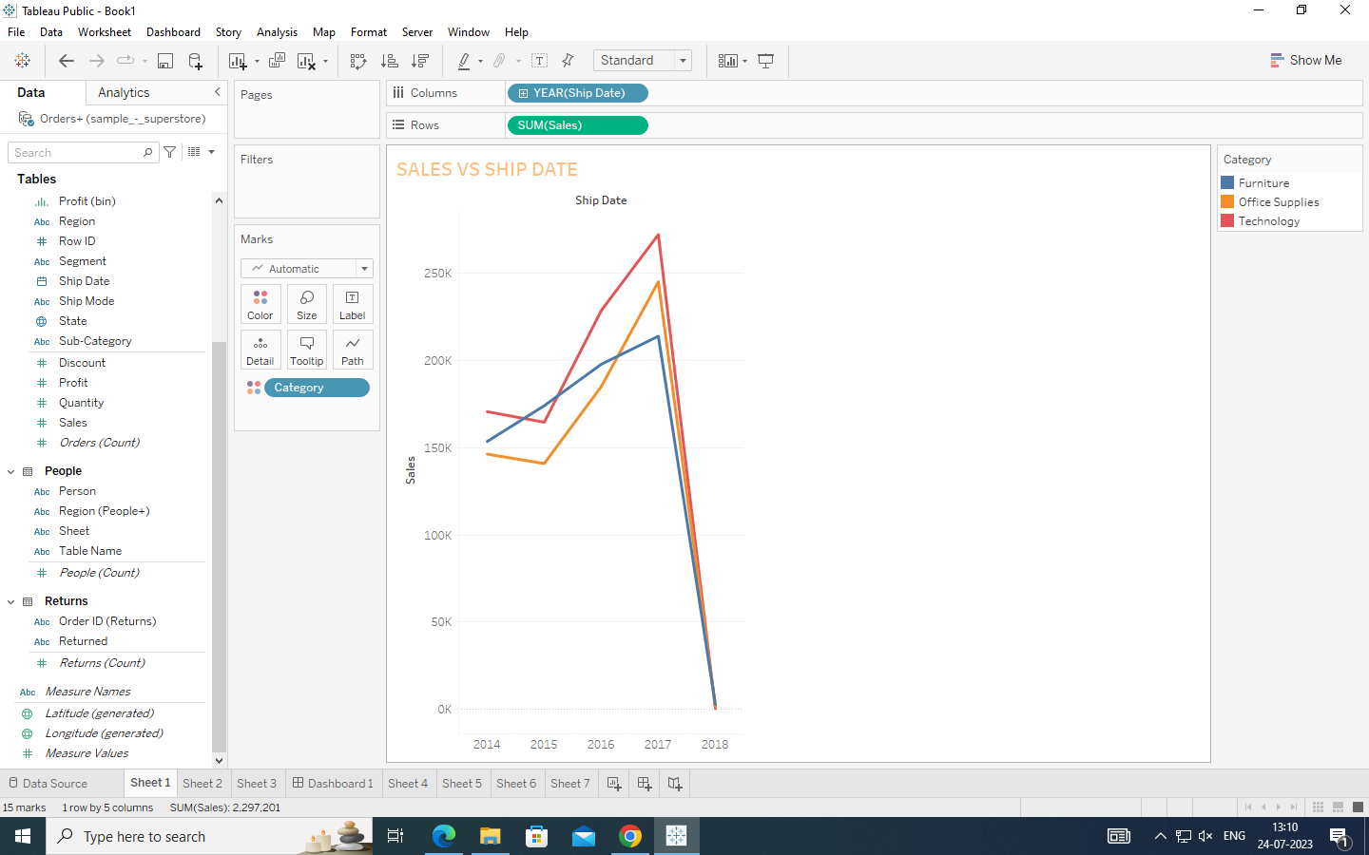

In this sheet i have used the line graph with year and sales with the categories.

There are 3 categories. Years from 2014 to 2018

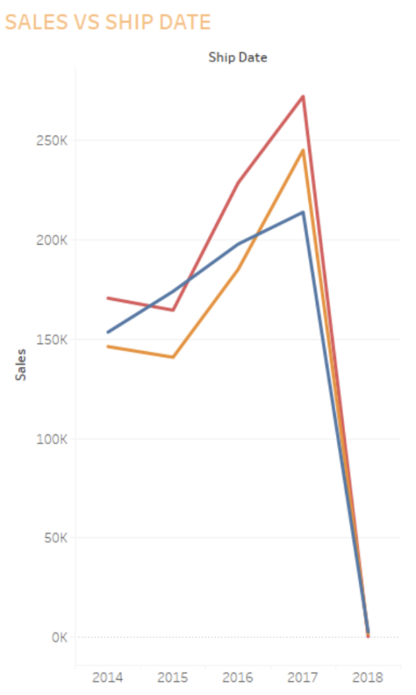

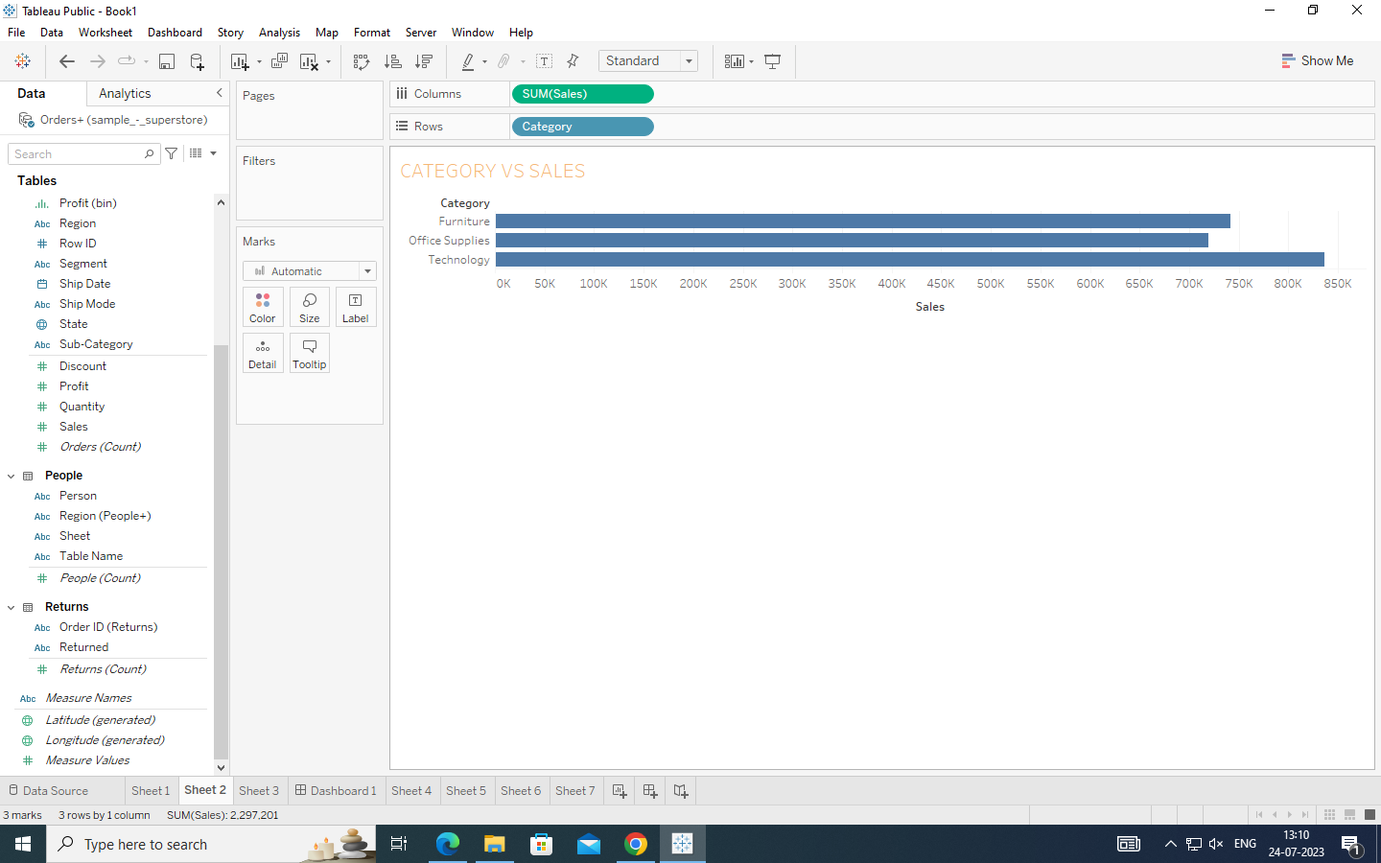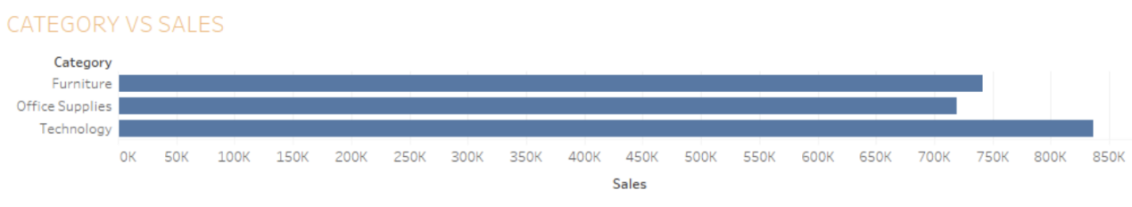

There are 3 categories:

Furniture-750K

Office Supplies-710K

Technology-840K

This chart is based on category vs sales.

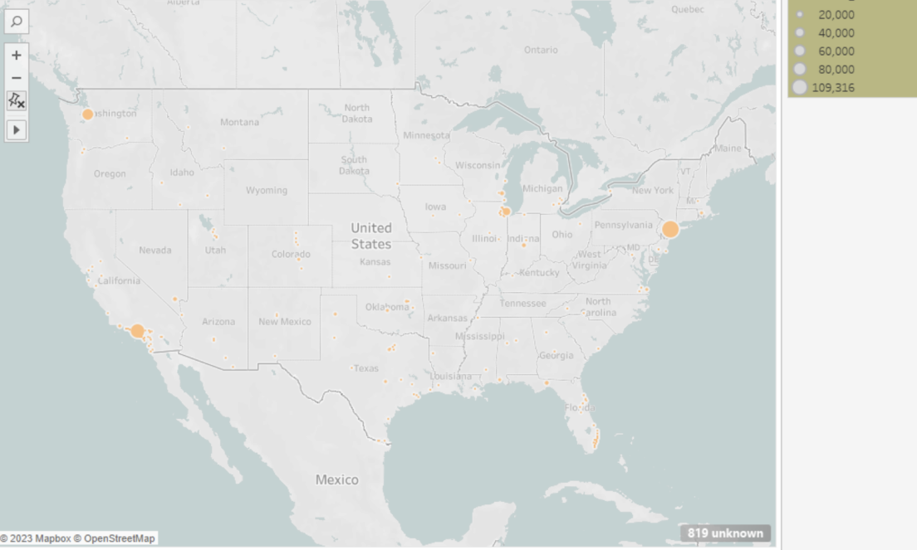

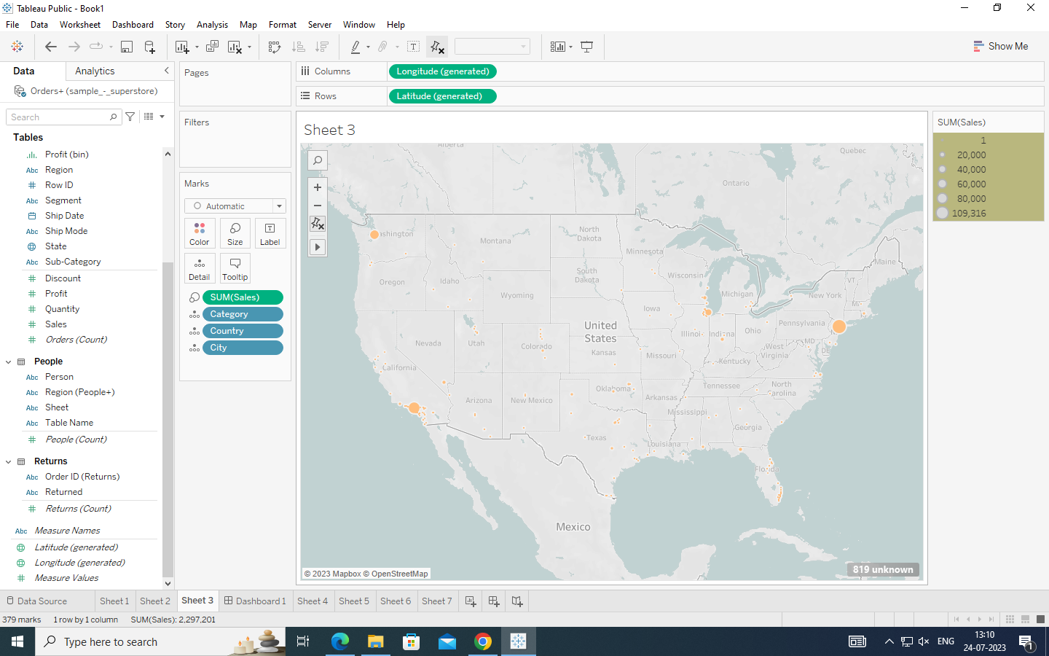

In this map the most sold areas are in the bigger circle and least are in small or dot.

There are sales, category, country and city

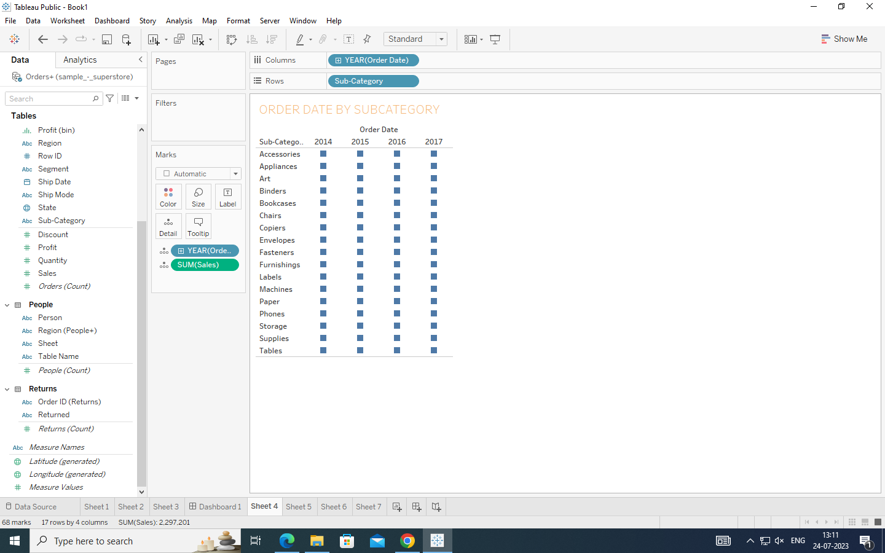

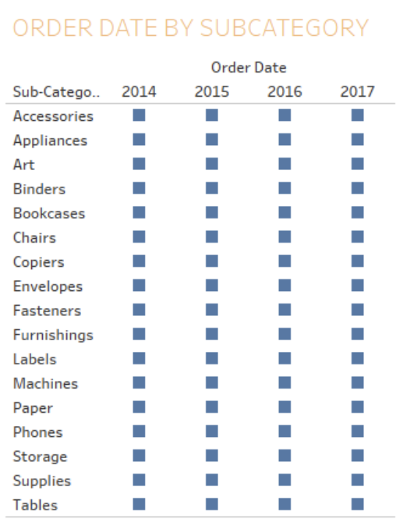

This chart shows use about the sub-category and year of sale

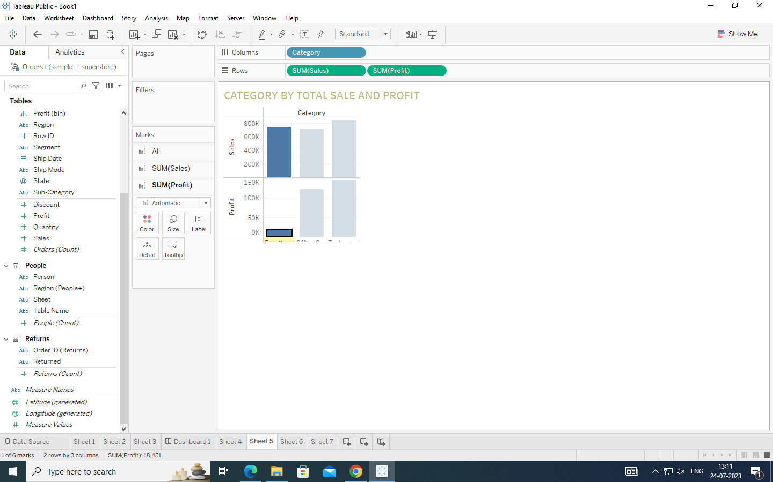

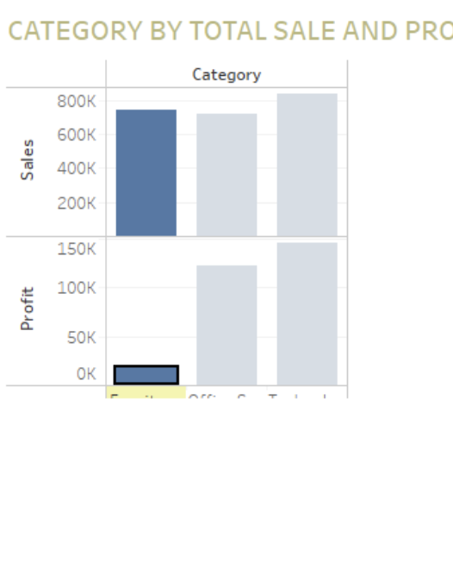

This chart has 3 variables sales and profit at one side and category on other side

This show the profit and sales in each category

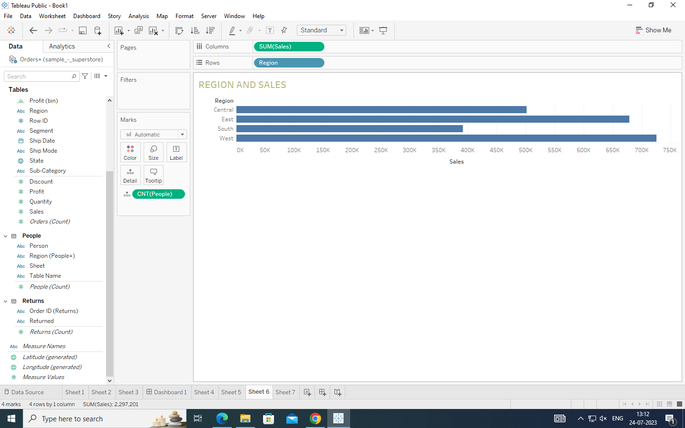

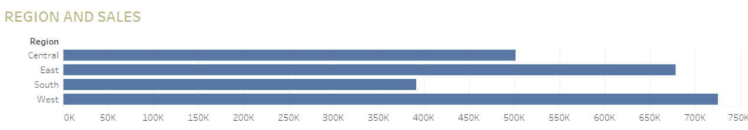

Region vs sales chart is used to show us how was the sales in every region

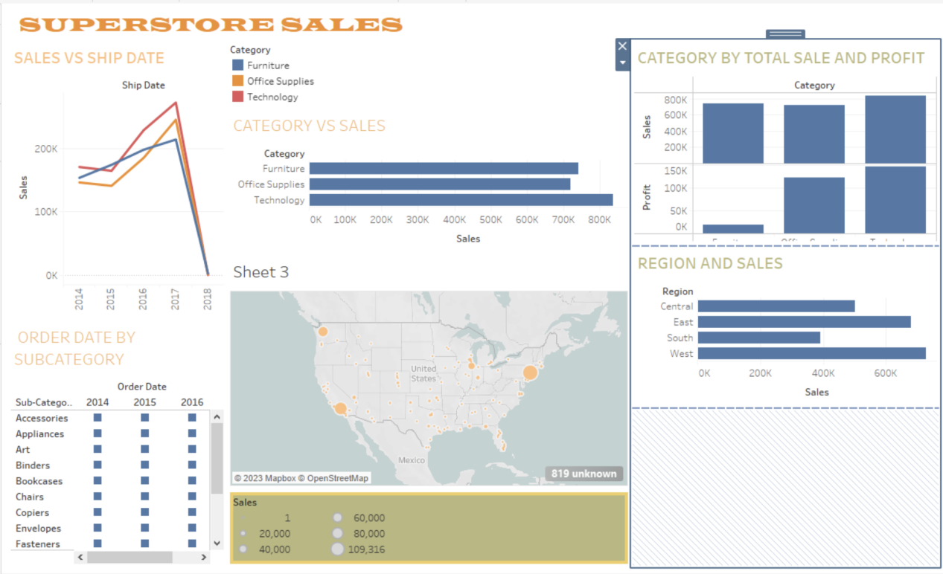

This dashboard is a combination of all the above chart and sheets